**Tire Drop-Off**

https://www.dropbox.com/s/oseldwnry9xqv7s/GCSE_Logo_hrz_COLOR-WEB.png?raw=1

**2021 Collection Dates**

**September 30th October 28th**

**Thursday, 9:00 am – 11:00 am**

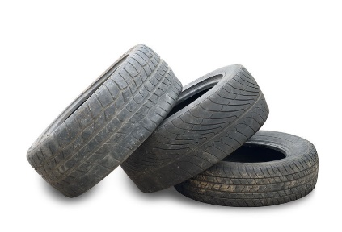**Tires on or off rims will be accepted. There is a small fee per tire:**

**Car or Light Truck = $1.00 per tire**

**Semi-Truck = $2.00 per tire**

**Agricultural = $5.00 per tire**

* **Tires accepted at the discretion of Greene County**
* **Tires accepted from Greene County residents and properties only**
* **Businesses are not eligible to participate**

**Register with the Greene Soil and Water Conservation District**

**1363 Burnett Drive, Xenia, OH 45385**

**Phone: 937-416-6906, E-mail: greeneswcd@outlook.com**

**Drop-Off Location:**

**Greene County Environmental Services**

**2145 Greene Way Boulevard, Xenia, OH 45385**

**Phone: 937-562-5925**

**Funding Provided By:**

